1. 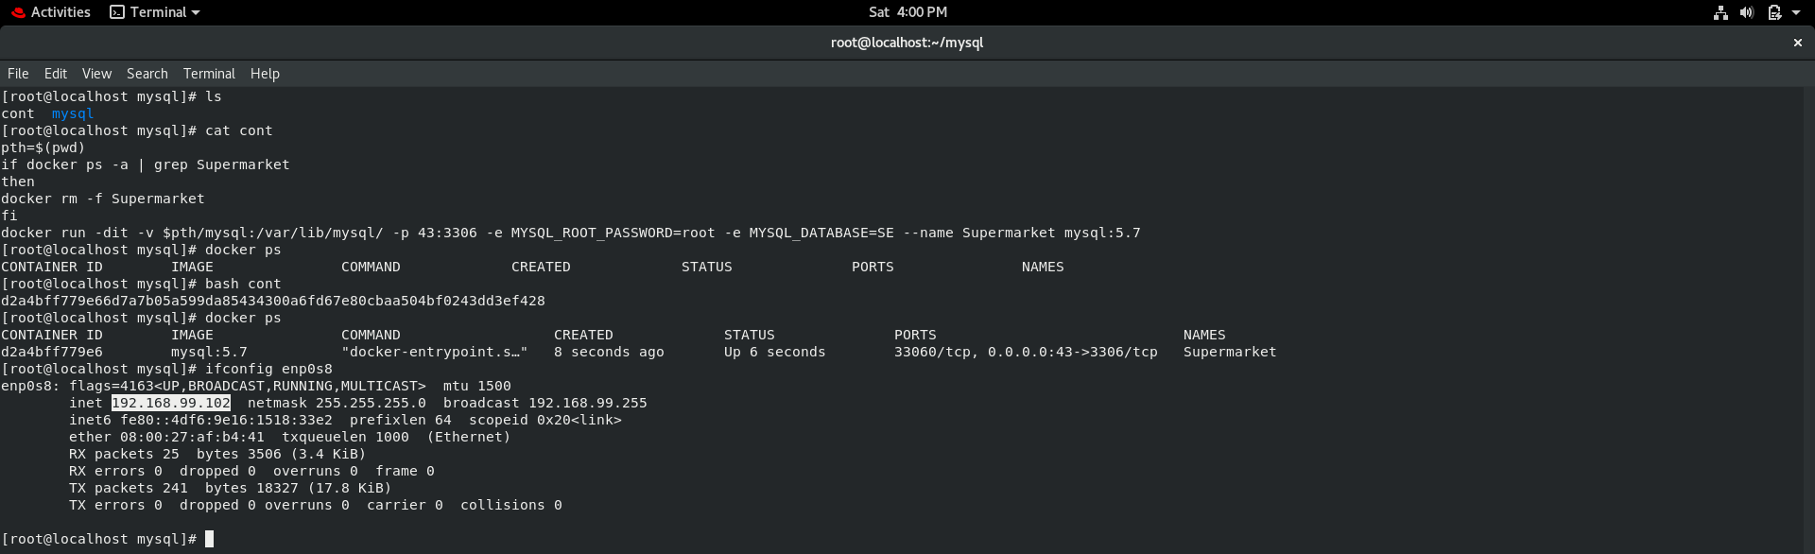First we are launching Container in Redhat VM.
2. Now we are accessing our java program from windows where we installed java and we pass a IP address of VM where our docker container is running as a argument.

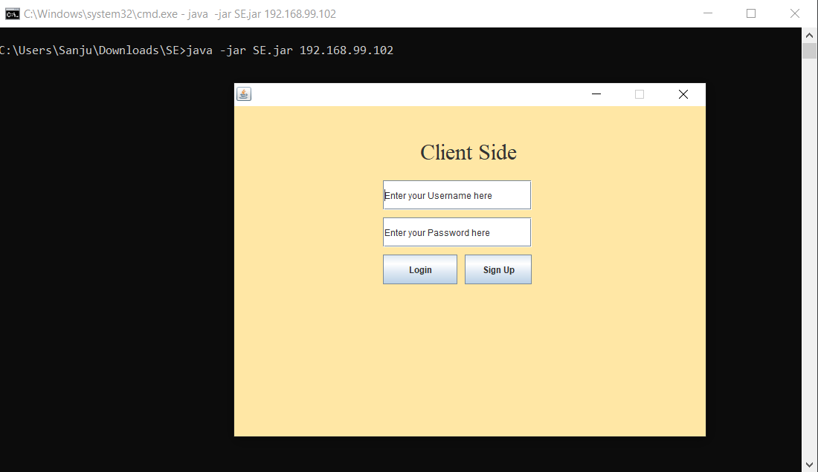

1. While creating new user we are trying to show you some validation which we perform while creating the new user.

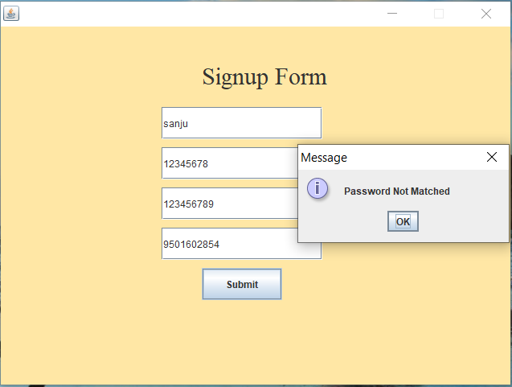

If password not matched then it will show an error.

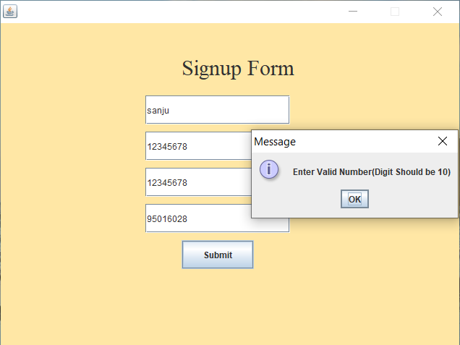

Phone number should be 10 digit

We also performing validation in username so that username can’t be same

IF user pass all these conditions then only he/she can create his/her account

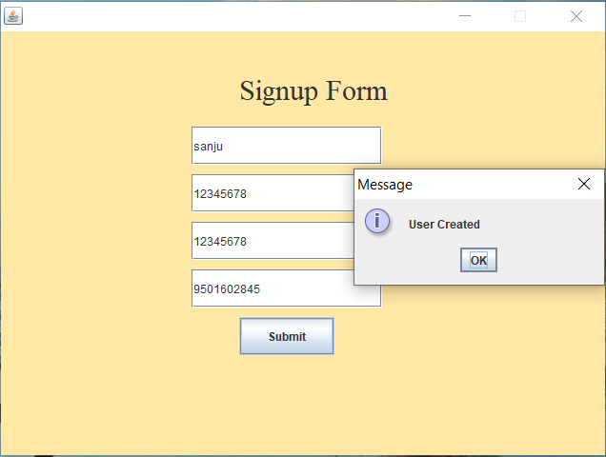

1. Now we are trying to LOGIN(IF details is wrong then it will show an error)

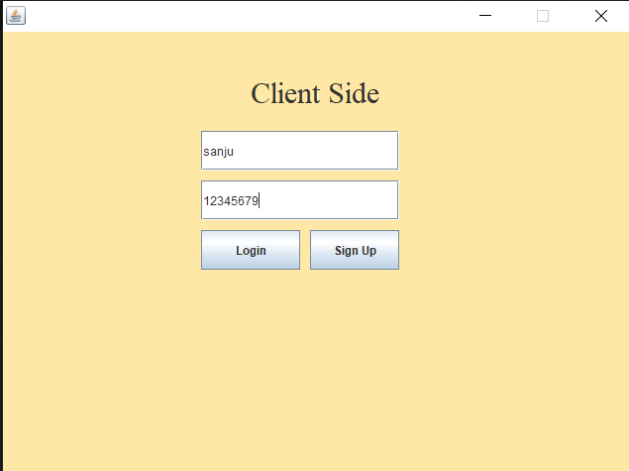

1. If details is wrong then it will you this error

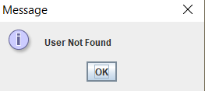

1. Now Again we entering correct Info

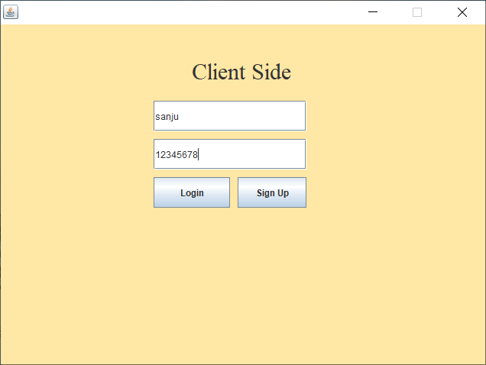

1. If details is right then user will Login to app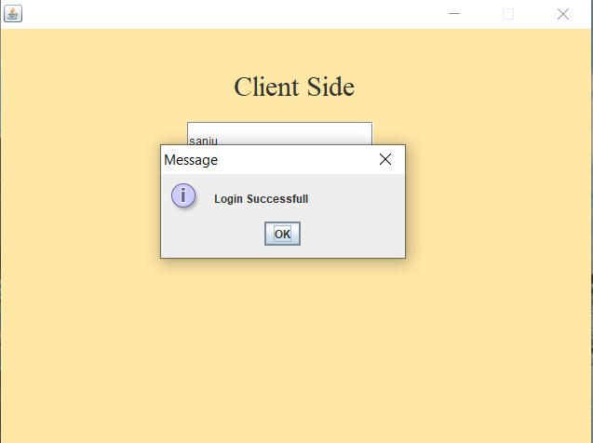
2. After login user will able to see product menu

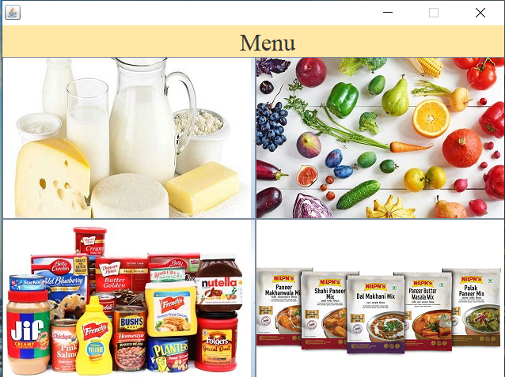

1. Now user can see number of product in sale and how much discount on each product

Note: It shows only those data which have only 1 month expiry date left not whole list.

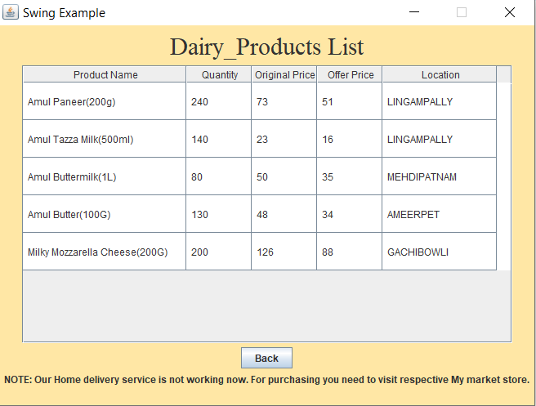

1. Now we are checking data on mysql is it is going on mysql or not..

